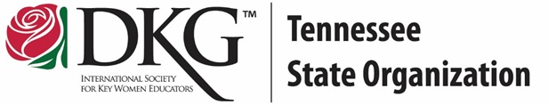
Member Education Video
Online Learning Module

International Projects
Name: Chapter: DKG #:

- DKG partners with UNICEF to support Schools for Africa. List five of the 11 countries in Africa where DKG hopes to secure a brighter future for Africa’s children.

- List three of the life skills taught in the Schools for Africa curriculum.

- What are two specific ways that donations from DKG members are supporting children in Africa?

- The second charity DKG International supports is SEE which stands for _______________ _____________- ____________ _______________.

- What is one way your chapter could contribute to SEE in your community?

