EEC Corner Spotlight
Chapter Program & Projects

Program X Project Icebreaker
Title: ZETA BOOK DONATION to all (51) Knox County Elementary Libraries (Yellow: A Life’s Journey by Dr. Nola Isobe and Illustrator, Chi Warner)

Summary: (limit 100 words)
Dr. Nola Isobe, a KC ELL teacher gave a presentation at our February meeting entitled “Teachers’ Impact on Students Dealing with Traumatic Situations”. She wrote a book, Yellow: A life’s Journey about her Appalachian growing up experience and how a teacher impacted her life. Dr. Isobe and her illustrator, Chi Warner attended our August 23rd meeting and she did her first book signing. ZETA purchased and delivered 51 copies of her book to KCS Library Media Department. It was an honor for ZETA to be able to purchase these books for all KC Elementary School Libraries and Knox County students.

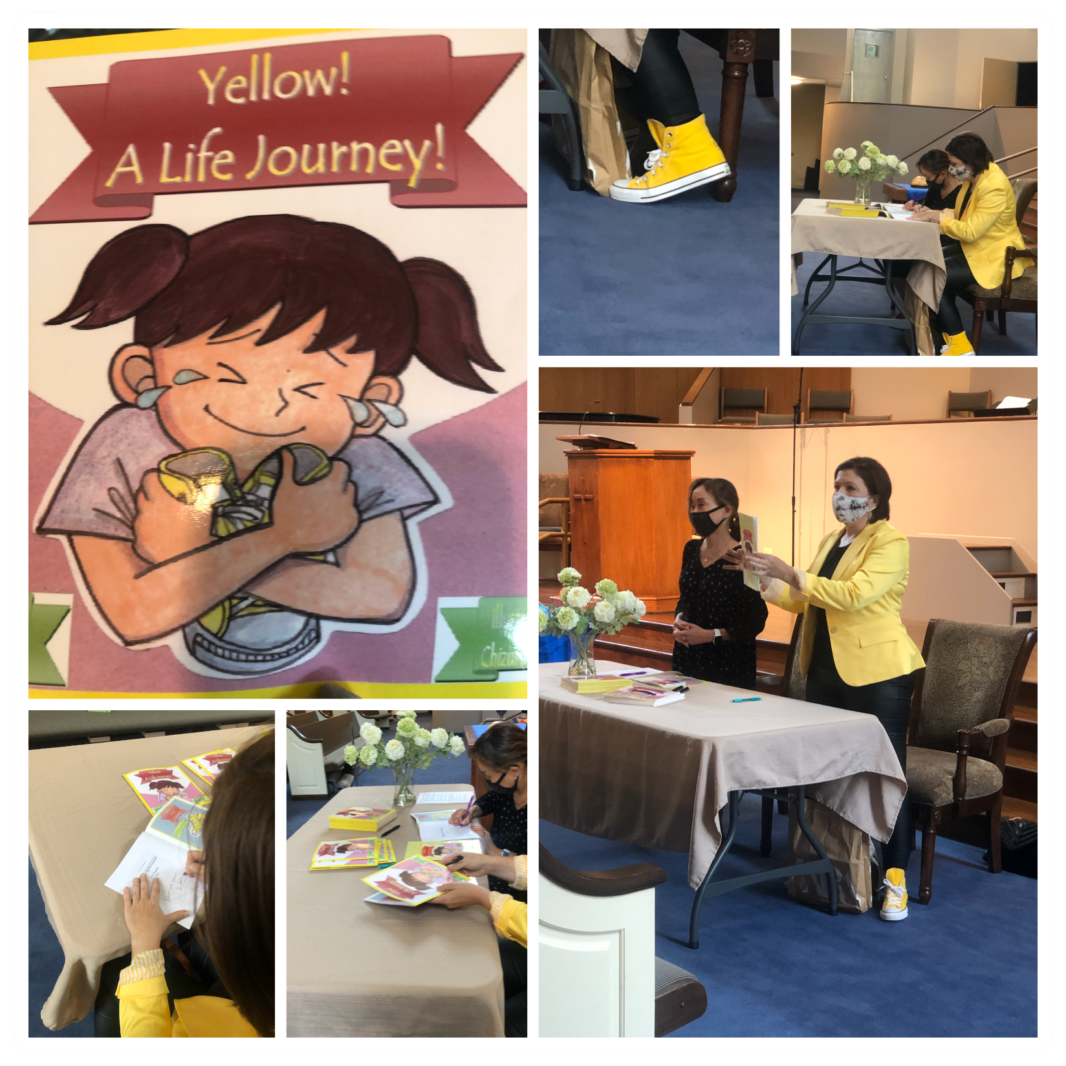

Contact Information:
Name:
Myra S. Sowder
Chapter:
Zeta
Email: (optional)
Sowdermossy868@gmail.com
Photo Release: (optional)
X I give permission to the Tennessee State Organization of Delta Kappa Gamma Society International to use and publish my photos, videos, audios for EEC Corner Spotlight submissions.

Submit EEC Spotlight form to: Marsha Brewer First Vice President to earn Maycie Points for a project or program submission – gnash81@comcast.net
NOTE: Chapters may also submit this form/information to the Tennessee State Editor for possible submission to the DKG Tennessee News to earn points for the Chapter Communication Award – mnsteeneditor@gmail.com
Bottom Line – you are using one form for 2 purposes (EEC Submission and DKG Tennessee News Submission).

