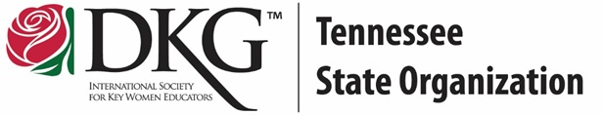
Member Education Video
Online Learning Module

TN State Organization Leadership Training
Name: Chapter: DKG #:

- When are the Beginning Level Tennessee State Organization Leadership Management Seminars offered to members regardless of length of Society membership?

- When are the Advanced TNSO Leadership Management Seminars are offered to all Beginning Level Seminar graduates?

- Name three past Advanced Level Seminar consultants who have served as International Society Presidents.

- What are two sessions of the Beginning Level Seminar that would improve your leadership skills? Why?

- Read a synopsis of both The Art of Possibility and One Piece of Paper. Which advanced leadership seminar book would you most like to study? Why?

